

**LINTHICUM ELEMENTARY SCHOOL**

**National Blue Ribbon School**

LES Tigers Raise Your Paws High –

Persevering Attitudes Will Succeed!

Newsletter: The Herald – March 2018



**Dates to clip and post → →→→→→→**

**This month at Linthicum Elementary – March**

**2 Schools Closed-Parent/Teacher conferences**

**5-23 MISA for grade 5**

**6 Chick-fil-A Spirit Night 4-8pm**

**9 Interims to be sent home**

**9 Multicultural Night** **6-8pm**

**21 Vision & Hearing Rescreen**

**21 Italia’s Corner Café Spirit Night 4-8pm**

**23 Movie Night- Coco 7:30pm**

**27 Paradise Donuts Spirit Morning 5:30-9:00am**

**28 Spring Parties!**

**29-April 2nd – Easter/Spring Break- Schools closed**



*From the Principal’s Pen* 

The Principal’s Pen is now located on our website!

Thank you

**SchoolStore.com**

**Don’t forget when doing your online shopping that you could be helping Linthicum Elementary School by going to SchoolStore.com and enter our school’s ID number 151155. LES receives money from each purchase made through SchoolStore.com**



**Linthicum Elementary**

**Values Our Students!**

**Mission Statement**

***At Linthicum Elementary School*** we work collaboratively with parents, colleagues, students, and the community to foster academic excellence, lifelong learning and responsible citizenship.

**Vision Statement**

***The Linthicum Elementary School*** aspires to become a growing Professional Learning Community by:

◻ Educating staff and the community to meet the needs of an increasingly diverse population and advancing the level of achievement for all learners.

◻ Involving members of the Linthicum Elementary School community to internalize and exhibit respect of self, others, learning, and property.

◻ Enhance citizenship awareness and contribute to the betterment of the community.

C:\Documents and Settings\cshank.AACPS-CORP.000\Local Settings\Temporary Internet Files\Content.IE5\ERRU072X\MC900233954[1].wmf

C:\Documents and Settings\cshank.AACPS-CORP.000\Local Settings\Temporary Internet Files\Content.IE5\09NPSXDY\MC900054089[1].wmf



**IMPORTANT REMINDER FROM THE** TRANSPORTATION DEPARTMENT

* **SCHOOL BUS LOOPS ARE DESIGNATED FOR SCHOOL BUSES ONLY. NO PARKING IS PERMITTED IN THE BUS LOOP DURING THE SCHOOL DAY, 8-4:00**
* **IF YOU MUST PICK UP YOUR CHILD FOR ANY REASON, PLEASE USE THE DESIGNATED PARKING LOTS AND DO NOT PARK IN FRONT OF THE SCHOOL.**

**YOUR COOPERATION IS GREATLY APPRECIATED**

C:\Documents and Settings\cshank.AACPS-CORP.000\Local Settings\Temporary Internet Files\Content.IE5\INLV1534\MC900134537[1].wmf

C:\Documents and Settings\cshank.AACPS-CORP.000\Local Settings\Temporary Internet Files\Content.IE5\TPZY35KT\MC900398219[1].wmf

***STUDENT OF THE MONTH For February–***

C:\Documents and Settings\cshank.AACPS-CORP.000\Local Settings\Temporary Internet Files\Content.IE5\INLV1534\MC900426082[1].wmf***The Student of the Month for February is Jackson B.  Jackson was selected by his teachers because of his hardworking attitude and perseverance.  He is responsible and always follows the Linthicum four respects.  Jackson works well with other students and tackles problems with an optimistic attitude. It was these characteristics that helped him to be chosen as a safety patrol.  Additionally, he consistently completes is homework and works hard in all of his classes. The fifth grade teachers are proud to announce Jackson B. as our Student of the Month.***

***Congratulations!***



C:\Documents and Settings\cshank.AACPS-CORP.000\Local Settings\Temporary Internet Files\Content.IE5\INLV1534\MC900398227[1].wmf

**CONNECT ED CALLS**

**LES uses the Board of Education’s automated service (Connect Ed) to get important information out to parents and students. Please check your messages for these very important calls so that you are aware of all that is going on at LES and when there are changes to schedules. If you are not getting these calls it is very important that you let the office know so that we can update any numbers that may have changed from the beginning of the year when you completed your child’s emergency form. The automated system used as LES is the same system the Board of Education uses to get information to you from the Board concerning, calendar dates, changes in dates/activities and important weather information. Remember to check these messages, before you call the school, as they come to you so you do not miss any important information that you or your child needs to know. It’s very important to us that you know all the information you need to as soon as we get it.**

**Thank you for your help!!**



**Wanted**

**SUBSTITUTES**

**Lunch/Recess Monitors**

**$10.00 per hour**

**Lunch/Recess Coverage is for**

**2 hours each day worked**

**Lunch/Recess Monitors are required to pay for fingerprinting prior to their employment.**

**If you are interested in becoming a substitute lunch/recess monitor please go on line to apply at** [**www.aacps.org**](http://www.aacps.org)**. to apply.**

**Thank you**

**C:\Documents and Settings\cshank.AACPS-CORP.000\Local Settings\Temporary Internet Files\Content.IE5\TPZY35KT\MC900232101[1].wmf**

**C:\Documents and Settings\cshank.AACPS-CORP.000\Local Settings\Temporary Internet Files\Content.IE5\09NPSXDY\MC900436041[1].wmf**

**PLAN AHEAD**

**SPRING/EASTER BREAK**

**March 29 – April 2, 2018**



**KINDERGARTEN REGISTRATION**

**BEGINS APRIL 4, 2018**



**PLEASE SUPPORT YOUR PTA**



**Chick-Fil-A Night**

**March 6 4-8 pm**



**Italia’s Corner Café Night**

**March 21 4-8 pm**

C:\Documents and Settings\cshank.AACPS-CORP.000\Local Settings\Temporary Internet Files\Content.IE5\TPZY35KT\MC900234181[1].wmf



**HELP LES EARN MONEY**

**ShopRite Rewards**

**Help us earn money for our school by registering your ShopRite Club Card. Each time you shop at ShopRite at 6710 Ritchie Hwy, Glen Burnie and use your card, LES will earn money from your purchases. Make sure you register your ShopRite card.**

**C:\Documents and Settings\cshank.AACPS-CORP.000\Local Settings\Temporary Internet Files\Content.IE5\09NPSXDY\MC900044899[1].wmf**

**Out of Area Continued…..**



**FORMS FOR CURRENT OUT OF AREA STUDENTS WILL BE SENT HOME WITH YOUR STUDENT. IF YOU HAVE NOT RECEIVED YOUR FORM PLEASE CHECK YOUR CHILD’S BOOKBAG AND RETURN YOUR FORM ASAP. PLEASE CALL THE OFFICE IF YOU DID NOT RECEIVE ONE.**

**THANK YOU.**

**C:\Documents and Settings\cshank.AACPS-CORP.000\Local Settings\Temporary Internet Files\Content.IE5\09NPSXDY\MC900388756[1].wmf**

**Multi-Cultural Night March 9th, 6pm-8pm  
See you there!**



Linthicum Elementary’s PTA has linked us up with **SMILE** through Amazon. This doesn’t cost you anything and you don’t have to set up a new account. If you shop through Amazon for anything, instead of going to amazon.com, go to **smile.amazon.com**. All you need to do is register for Linthicum Elementary School. Once you do that a few times it will automatically pop up and ask if you want your purchase amount to go towards LES and our school will get a percentage of sales.



MOVIE NIGHT IS COMING!

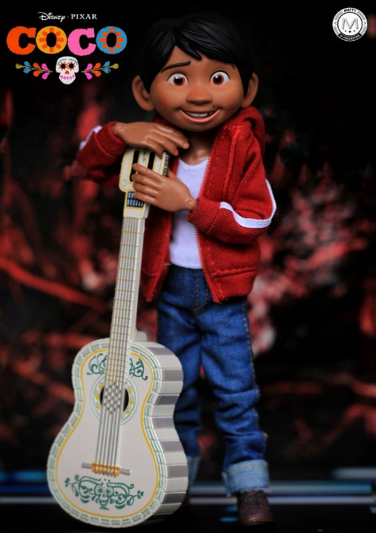

Rated PG

The PTA is hosting a family movie night on Friday, March 23rd at 7:30 p.m. We will be showing Coco (Rated PG) and will begin admittance at 7:15, as PTA members are preparing the gym for the movie presentation.

If your family would like to join us for movie night, we kindly ask that everyone be mindful of those around them and keep talking to a minimum. We also ask that adults keep an eye on their children throughout the evening, ensuring that they are not running at the back of the gym, or loitering in the bathrooms and hallways.

We will be offering free popcorn and drinks to those who join us. To help alleviate running out of popcorn, drink spills and a big mess at the end of the night, we will be handing out tickets to each child when they arrive. Those tickets will be redeemed for 1 bag of popcorn and 1 drink (a capri sun-like drink). Adults will also be welcome to 1 bag of popcorn. If you bring additional drinks, please use a cup with a lid to avoid spills. Please also be mindful and gather your trash at the end of the evening.

Thank you for your understanding. We thank you in advance for what we know will be an enjoyable evening. Don’t forget a blanket or chair!