|  |
| --- |
|  |
| Grade 5 Parent Newsletter |
|  |

**Adding and Subtracting Fractions**

Dear Parents,

In this unit, students will discover how to add fractions with unlike denominators using visual models such as fraction strips and number lines. They will also find common denominators using multiple strategies, including like denominators, finding common multiples, and multiplying the denominators. To further develop their skills, they will have the opportunity to estimate the sums and differences of fractions to help them solve word problems.

Thank you for your support,

Your Child’s 5th Grade Teacher

**How can you help your child be successful in mathematics?**

|  |
| --- |
|  |
| **Important Concepts:** -students will add fractions with unlike denominators using visual models.  -students will find common denominators using various strategies.  -students will have the opportunity to estimate the sums and differences of fractions.  **Misconceptions:** Students may not find a common denominator before adding. Students may add the numerators together and then add the denominators.  Students may struggle to determine the appropriate operation when solving a word problem.  **Things to Do:** To help students to find a common denominator and discover why adding across is incorrect, have them draw a visual representation of fraction towers or a number line. |

**Vocabulary:**   
**Fraction:** a number that names equal parts of a whole; a fraction names a point on the number line and can also represent the division of two numbers.

**Numerator:** the number above the line in a fraction. It tells how many equal parts are described.

$\frac{2}{3}$

**Denominator:** the number below the line in a fraction. It tells how many equal parts are in the whole.

$\frac{2}{3}$

**Equivalent fraction:** two or more fractions that have the same value. They name the same part of a whole and the same point on a number line.

**Common denominator:** a number that is a common multiple of the denominator of two or more fractions.



**Strategies to Support Student Learning**

Students will solve addition expressions with unlike denominators. Students will use their knowledge of equivalent fractions to to solve.

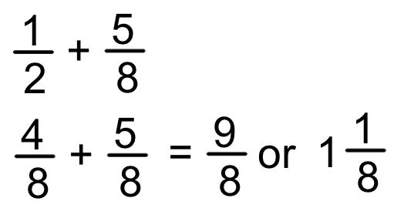

Students can multiply to find common denominators.

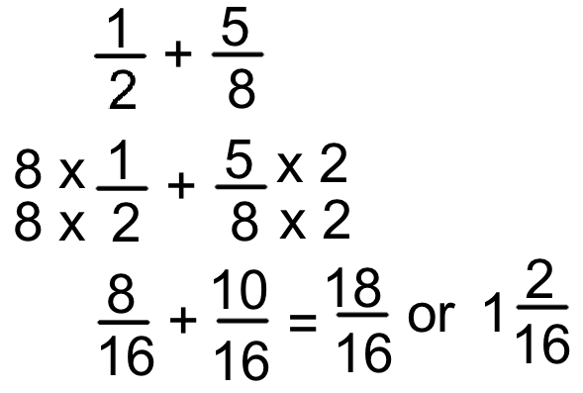

Adding mixed fractions with unlike denominators. Students will find equivalent fractions to help them solve.

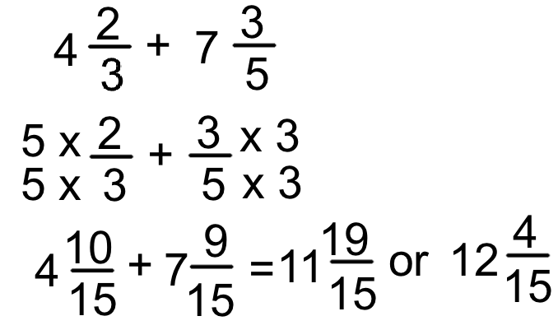

Students create equivalent fractions to subtract using a variety of strategies.

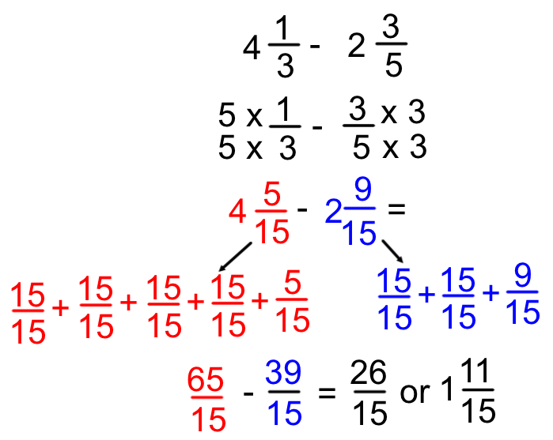

**Games to Support Home-to-School Connection**

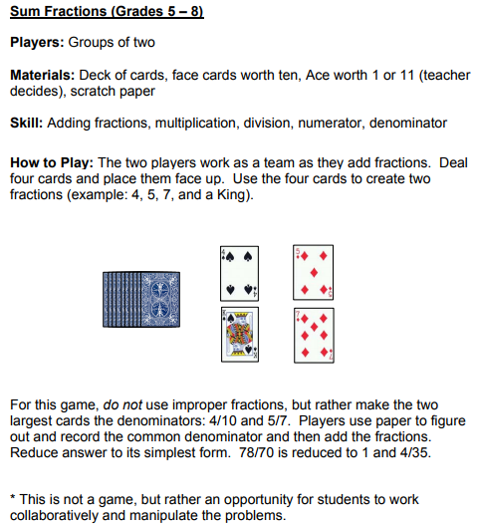

Acing Math (One Deck At A Time!): A Collection of Math Games

*This activity could also be used for subtracting fractions. If you wanted to make it into a game, you could each draw four cards and add the fractions. The player with the greater sum wins the cards.

**Real World Connections**

